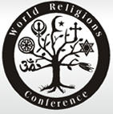 World Religions Conference 

How Religion Can Protect the Environment
Speakers from Multiple Faiths

Tuesday October 21, 2008
6:00PM – 9:00PM
Student Alumni Centre, Olds College

* Snacks will be served  * Bring Food Donations | Sponsors:  Ahmadiyya Muslim Jama’at, Calgary NW  Olds College Students’ Association

