Ahmadiyya Muslim Women’s Association of Peel Region
Invites you to an Interfaith Symposium

ON

SUNDAY, OCTOBER 21ST, 2007

Speakers of the following faiths will be presenting:
ZOROASTRIANISM
HINDUISM
BHUDDISM
SIKHISM
JUDAISM CHRISTIANITY
ISLAM

LOCATION: 1194 Matheson Blvd. East
Mississauga, ON L4W 1R2

2:30 PM- REGISTRATION
3:00 PM- PROGRAM BEGINS
6:00 PM- PROGRAM ENDS

*Free Parking available
*Refreshments will be served

For more information contact: (905) 569-0969
or (416) 829-8877
Directions:

From Highway 401:

- HWY-401 Collectors (signs for RR-4/Dixie Rd)
- Take exit 346 for Dixie Rd (2.2km)
- Go south on Dixie Rd (0.7 km)
- Turn right at Matheson Blvd E (0.9 km)
- Turn right into 1194 Matheson Blvd

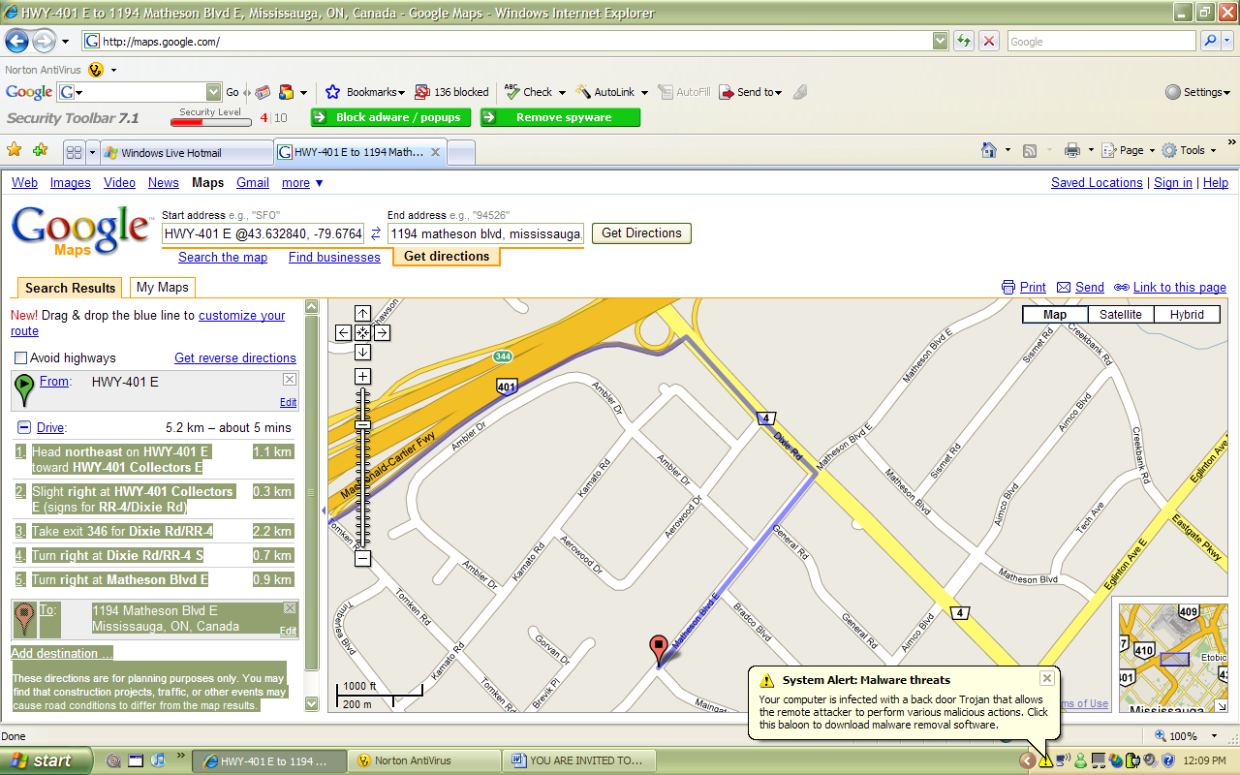

From Highway 403:

  - Take the Eastgate Pkwy/Cawthra Rd (0.8 km)
  - Merge onto Eastgate Pkwy (0.8 km)
  - Turn left at Tomken Rd (2.0 km)
  - Turn right at Matheson Blvd E (0.5 km)
  - Turn left into 1194 Matheson Blvd.

